PHASE 3 OF 8
Project Design Phase
Auto Ticket Classification using Flow Designer

Project | Platform | Team
Auto Ticket Classification using Flow Designer | ServiceNow (Flow Designer) | SAMRIN HASRAA S  SALMA FARHANA M  SAJITHA FATHIMA S K  FATHIMA M

1. Solution Architecture
A student submits a ticket into the custom table. The Flow Designer flow is triggered by the record creation, classifies the ticket by updating Category and Subcategory, and then emails the caller.
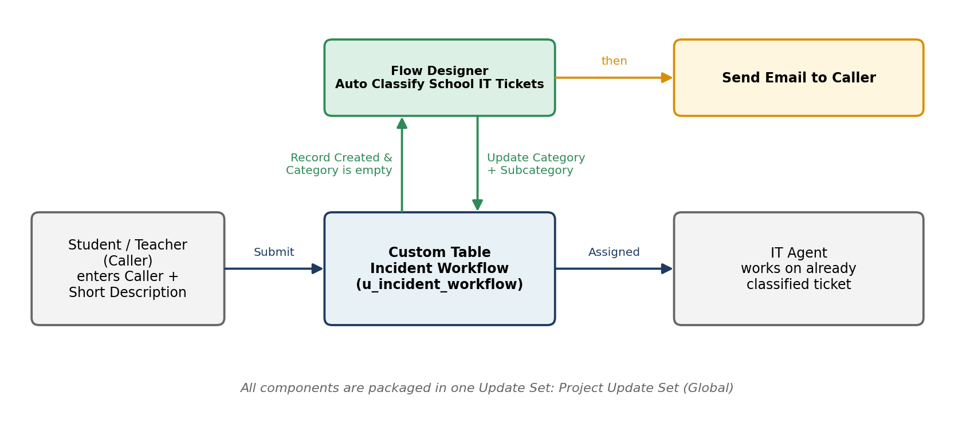
Figure 3.1 – Solution architecture

2. Data Model
Table: Incident Workflow · Name: u_incident_workflow · Auto-number prefix: INC · Access role: u_incident_workflow_user
Field Label | Column name | Type | Reference / Choices
Number | u_number | Auto Number | Prefix INC
Caller | u_caller | Reference | sys_user
Category | u_choice_2 | Choice | Network, Hardware, Access, Performance
Subcategory | u_choice_3 | Choice | Wi-Fi, Projector, Forgot Password, Slow Computer
Short Description | u_string_4 | String | –
Description | u_string_5 | String | –
State | u_choice_6 | Choice | New, In progress, On hold, Resolved, Closed
Assigned Group | u_reference_8 | Reference | sys_user_group
Assigned to | u_reference_9 | Reference | sys_user

3. Dependent Choice Design (Category → Subcategory)
Subcategory uses Use dependent field with Dependent on field = Category. Each Subcategory choice is tied to a Category through its *Dependent value*.
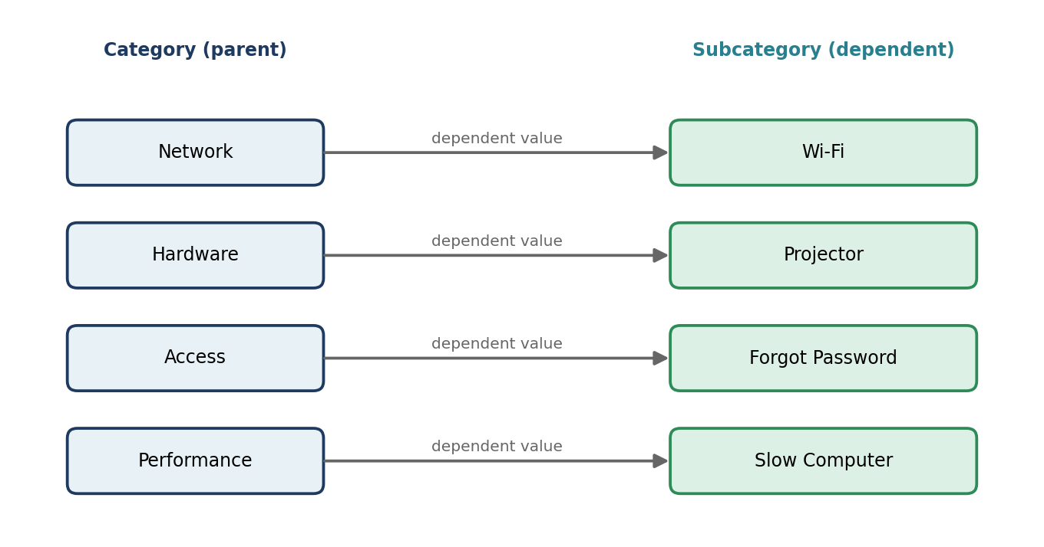
Figure 3.2 – Category to Subcategory dependency

4. Flow Design – Auto Classify School IT Tickets
Item | Value
Application | Global
Trigger | Record → Created
Table | Incident Workflow
Trigger condition | Category is empty
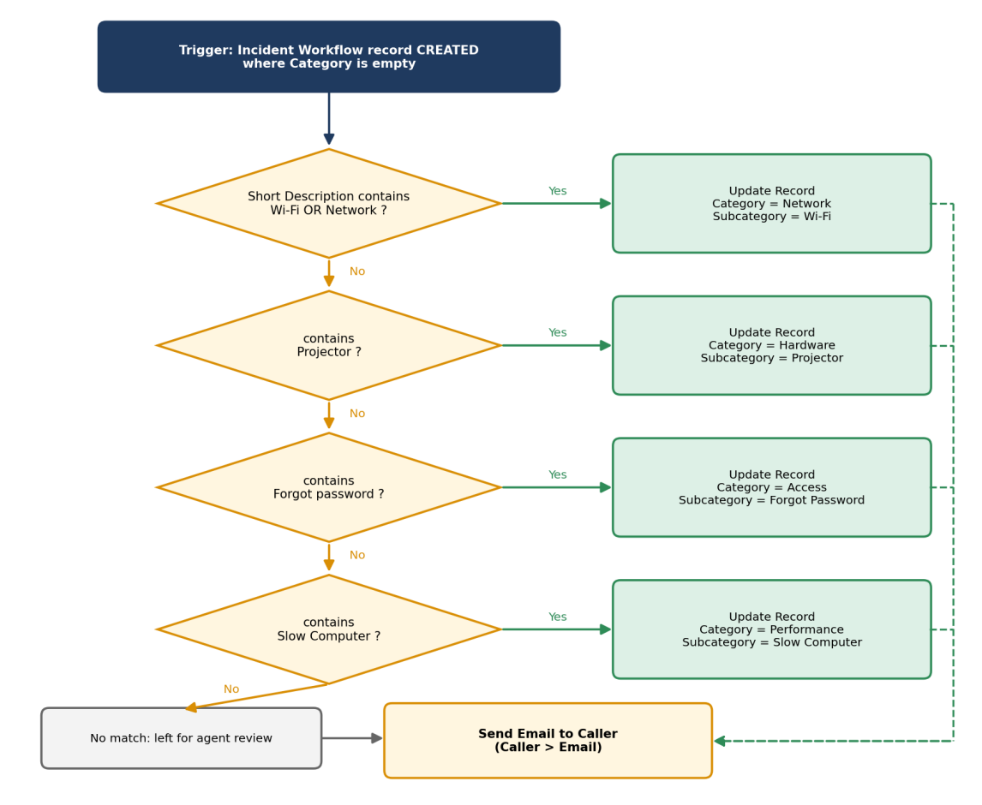
Figure 3.3 – Flow logic

Flow steps summary
Step | Element | Configuration
1 | If | Label *SD is Wifi or Network*; Short description contains Wi-Fi OR contains Network
2 | Update Record | Category = Network, Subcategory = Wi-Fi
3 | Else If | Label *SD is Projector or Hardware*; Short description contains Projector
4 | Update Record | Category = Hardware, Subcategory = Projector
5 | Else If | Label *SD is Forgot password*; Short description contains Forgot password
6 | Update Record | Category = Access, Subcategory = Forgot Password
7 | Else If | Label *SD is Performance*; Short description contains Slow Computer
8 | Update Record | Category = Performance, Subcategory = Slow Computer
9 | Send Email | To: Caller → Email; subject and body as designed below

5. Email Notification Design
Property | Value
Action | Send Email
To | Trigger → Incident Workflow Record → Caller → Email (data pill)
Subject | Your Request for the issue has been submitted
Body | Ticket confirmation message

6. User Interface Design
- The ticket form shows Number, Caller, Category, Subcategory, Short Description, Description, State, Assigned Group and Assigned to.
- The student fills only Caller and Short Description; Category and Subcategory are filled by the flow after Save.
- The Subcategory dropdown is filtered by the chosen Category.

7. Security Design
- ServiceNow creates default ACLs (create, read, write, delete) for the new table, protected by the role u_incident_workflow_user.
- Only users with this role (or admin) can access records; reference fields resolve only to existing users and groups.

8. Design Decisions
Decision | Reason
Keyword-based If / Else If logic | Simple, visible and no code
Trigger only when Category is empty | Avoids overwriting a category chosen manually
Dependent Subcategory | Prevents invalid Category–Subcategory pairs
Everything in one Update Set | Easy to move to another instance

